

Talispoint On-Line Directory
for Core Specialty / Comp MC

https://www-lv.talispoint.com/login/
Login: strata
Password: ccmsi99

Search Providers by name, address, or
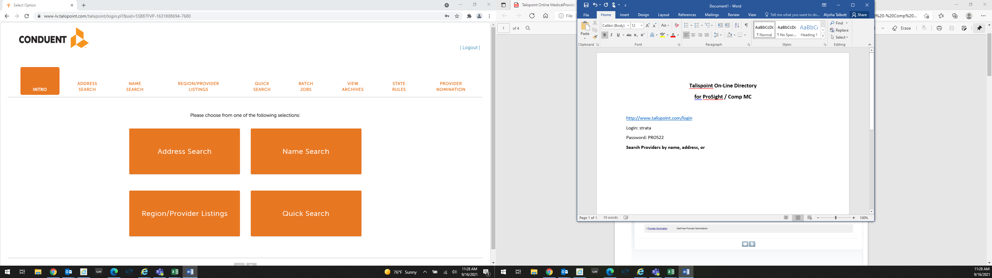

Define the search by distance, network and or Specialty:
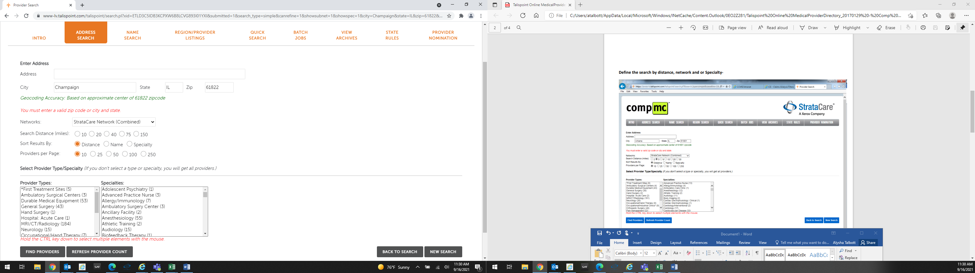

Export the results into a spreadsheet, directory or placard:
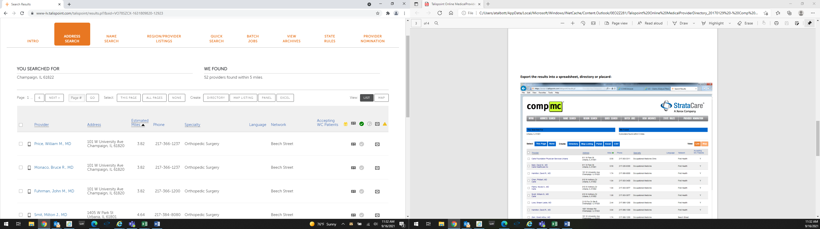

Pull up a map to see where providers are located compared to the target area:



